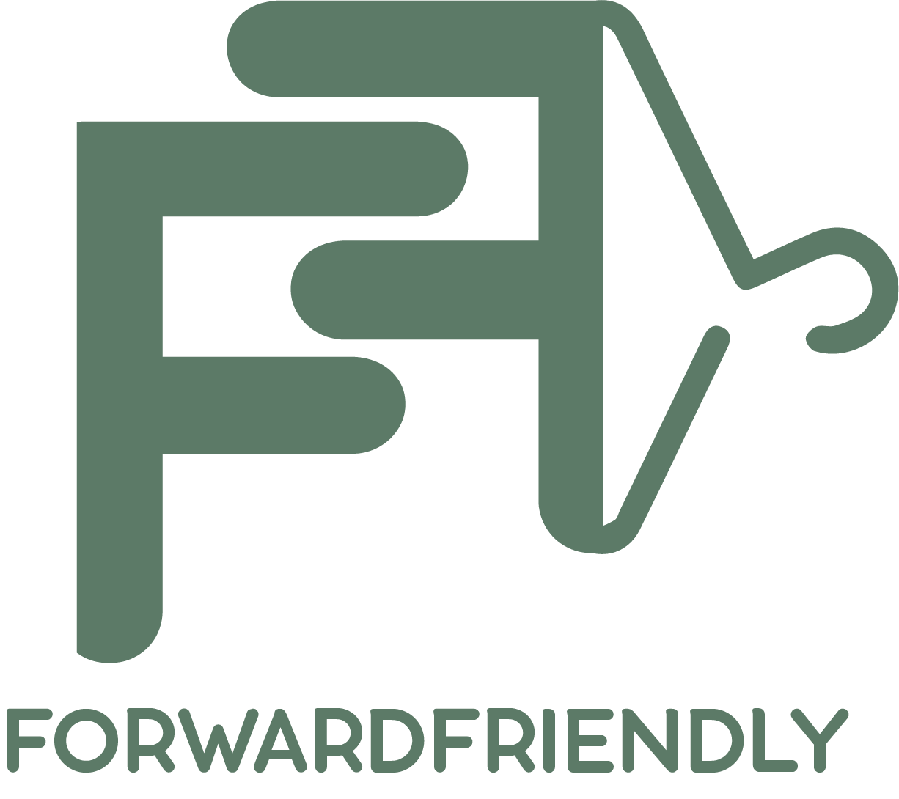

Project Summary and Analysis

Tirza Chase

Capstone IME695

M.A. in Interactive Media

Elon University

May 13, 2020

**TABLE OF CONTENTS**

**PROJECT SUMMARY ………………………………………………………………….…… 3**

**SOFTWARES USED**

**PROJECT TIMELINE ..………………………………………………………………….…… 4**

**DELIVERABLE ……… ………………………………………………………………….…… 5**

**RESEARCH CONDUCTED…………………………………………………………….…… 6**

**OVERALL CONTENT FOR WEBSITE *pg 6***

**QUIZ CONTENT *pg 14***

**PROCESS DOCUMENTATION……………………………………………………….…… 17**

**LOGO DESIGN**

**STYLE GUIDE/MOODBOARD**

**PERSONA *pg 17***

**CONTENT INVENTORY *pg 18***

**SKETCHES *pg 21***

**REFLECTION …………………………………………………………………………….…… 22**

**CREDITS ………………………………………………………………………………….…… 23**

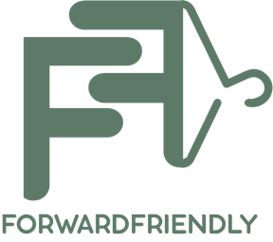

**PROJECT SUMMARY**

The purpose of Forward Friendly is to encourage the knowledge of fashion sustainability. This is an interactive educational website that offers a fun way to learn how to save the environment and enjoy fashion.

A consumer has the power to open new routes for purchasing items based on how we decide to wear, buy, and use fashion. The consumer alone has so much control, and with that comes responsibility. Forward Friendly is a platform to allow you to start the journey of become environmentally conscious about the things we see as “fashion”. This site is educational to support the environmentally conscious, but is targeted to 16 – 35 year-olds who are our everyday consumers in store and online with the power to control our environmental climate.

In this project, you will be able to learn about 3 important factors one should notice as a consumer of fashion. The first factor is the materials used. This aspect is over looked but is extremely important due to the potential effects it can have on the environment. Forward Friendly will allow you to view each material in depth by origin, composition, and environmental effect in a stylistic, visual manner. The second factor is labor laws. The sad side of fashion is about who is manufacturing the clothes, and how they can be poorly treated. Forward Friendly allows you to learn the processes, check on companies at your leisure, and view data analytics around the world where child labor has taken place from 2000-2019. The last factor is environmental effects. Forward Friendly helps break down how the textile/garment industry has affected the environment through animated infographic videos.

Altogether, Forward Friendly offers an interactive quiz, animations, visual storytelling, and tips to explain why the consumer should aim to learn more on how to be fashion-conscious. It is Forward Friendly’s mission for the user to become fashion forward and environmentally friendly.

**SOFTWARES USED**

* Adobe Illustrator
* Adobe After Effects
* Ceros
* Wix
* Tableau and R Studio

**PROJECT TIMELINE**

* Week 3: Deepen research on:
  + Sustainable Materials (what are they, where do they come from, how to use)
  + Un-Sustainable Materials (what are they, where do they come from, why to not use)
  + Which brands are unsustainable, what are the carbon footprint / water usage factors involved and what does that do to the Earth?
  + Ask Professor Walsh for help in R/R Studio to find a library in the tidy verse surrounding fashion brands and sustainability
  + Persona for the website **(due week 4: 2/25)**
* Week 4
  + Learn Ceros, Contact T.S. Designs about their sustainability methods, have full research done from week 3.
  + Think of name for the website and mission statement
  + Start sketching a sitemap and wireframe for the website
  + Create a mood board for the website
* Week 5
  + Come up with quiz questions and accompanying visuals for Ceros
  + Start sketching ideas for a name/logo/tag line
  + Develop a prototype in Adobe XD
  + ***At the end of the week, have a style guide***

---- Spring Break----

* Week 6:
  + Spring Break is this week; however, it would be best during your free time to start coding the basic HTML pages with a CSS style sheet following the style guide.
    - Mission statement/about page
    - Splash page
    - Home page
  + Take this time to get more familiar with Ceros and be ready to use it by Week 7
  + **Finalize the logo if you haven’t already**

---- Spring Break----

* Week 7:
  + Continue coding the website
  + Work on quiz in Ceros
  + Work on Parallax infographic
  + Begin thinking of animations
* Week 8:
  + Continue coding the website
  + Work on Parallax infographic and regular infographic
  + Finish Ceros quiz
* Week 9:
  + Learn how to add in the Ceros Quiz into the HTML as its own page
  + Continue coding the rest of the website
  + ***Have any animation prepped by this time to be completed or already done***
* Week 10
  + Be as confident as you can in your coded site at this point.
  + All quizzes, animations, infographics, and content are ready.
  + Tie up all loose ends to prepare for making the site live on week 11
  + Make usability test questions – Run them by Dr. Xu
* Week 11
  + Make site live through SQL and jQuery to the domain
  + De-bug and check for errors
* Week 12
  + Try to run usability test for the first version
  + Take feedback and edit your site
* Week 13
  + Continue editing the site
  + **Project beta is due (Thursday 4/30)**
* Week 14
  + Try to fix all remaining bugs
  + Re-upload the site through SQL and jQuery to the domain

**DELIVERABLE**

The final deliverable of Forward Friendly will be a website that is fully interactive, a quiz that allows you to test your knowledge, and fun educational content. This website will be responsive for both mobile and web.

**RESEARCH CONDUCTED**

Overall Content for the Website

# **Eco-Friendly Materials**

1. What are they made of?
2. Where can you find them? Where do they originate?
3. How are they made?
4. How is sustainability improved if used?

What are the names of each?

* + Recycled Materials
    - 1. Clothing made out of used plastics, papers, and metals. Also, anything once worn that can be reused can be recyclable but not recycled like cotton, wool, and down
    - 2. You can find them in old clothes given away or at your local market that sells plastic bags, old used paper, and metal scraps that have been discarded
    - 3. Most materials are made of a singular reused material, simply plastic or repurposed wool. Recycling a type of material depends on your local recycling option and if there is a market for that material.
    - 4. Sustainability is improved because you are not letting anything go to waste. Recycled means that the origin of some materials in the product when bought were new, recyclable means what you choose to be done with the product when finished.
  + Hemp
    - 1. A plant with great nutritional value that can be used for cleaning and building. This hemp is a different strain that the strain used for the drug.
    - 2. When the Hemp industry dwindled because of strict laws in many countries including the US, China became the world leading producer and the US imports the most hemp.
    - 3. Hemp is grown on a loose well aerated soil with high fertility and organic matter, it can be successfully grown in continuous rotation on the same soil for multiple years if watched for pests.
    - 4. Stronger than cotton substitute that requires less pesticides and herbicides. The inner fibers are tough and has a low impact on the environment. The recyclability and durability of hemp is long lasting and more reusable than wood pulp and synthetics.
  + Soy Silk/Cashmere
    - 1. Made of soy protein, a by-product of tofu manufacturing
    - 2. Soybean fiber originated from Henry Ford of Ford Motor Company, and was almost non-existent after WW2 due to the creation of rayon, nylon, and cotton. It was reintroduced in 1998. Now it is mostly sold in China
    - 3. Soy proteins are extracted from the residual by-product of soybean oil or tofu produce which is recycling. Manufacturing is eco-friendly by liquifying the protein and then wet spinning to produce the fiber. It is bio degradable.
    - 4. Highly sustainable source of organic fiber, grown without fertilizers/pesticides/herbicides.
  + Organic Cotton
    - 1. Cotton is a crop itself grown on farmed land
    - 2. Can be found in tropical and subtropical regions – Americas, Africa, and India. Traditional cotton is a destructive industry, being the biggest pesticides user. Cotton is 3% of the crops grown on farms but a quarter of the world’s use for pesticides.
    - 3. Grown without pesticides, non-genetically modified, and can use companion plants to help its growth.
    - 4. Unlike regular cotton, organic lacks pesticides used in the process. However less than 0.1% of global cotton production is organic. Without the pesticides, insects can remain in the ecosystem, biodiversity of plants are saved, and high organic matter can be retained preventing erosion. If dyed, the cotton is no good. Stick to its original colors of cream, light brown, and pale green.
  + Linen
    - 1. Made from cellulose fibers that derive from flax plants
    - 2. The flax plants are naturally grown all over the Mediterranean and Central Asia.
    - 3. Linen goes through a process called retting to separate the fibers from the Flax. Stronger than cotton, made with pesticides but with way less than cotton.
    - 4. Does not require an abundance of energy or water to produce, the entire plant is used to make linen leaving no waste or footprint. Naturally recyclable and biodegradable. When wearing linen, if its dyed it is no good. Look for its natural color or go for low impact dyes.
  + Lensing Tencel
    - 1. Tencel is a brand name for a type of lyocell – which is a form of rayon consisting of cellulose fibers made by bleached wood pulp.
    - 2. Produced by an Australian Company Lensing AG
    - 3. Made by a special drying process called spinning
    - 4. Requires less water and energy than cotton and is biodegradable. Uses a closed loop production process that recycles the petrochemicals to minimize harmful waste. If dye is used, it requires less than cotton so Tencel fabric dyed is an easier fix than cotton. The main concerns with Lensing Tencel is the amount of energy used and how unrenewable it is.

# **Non Eco-Friendly Materials**

1. What are they made of?
2. Where can you find them? Where do they originate?
3. How are they made?
4. How is sustainability improved if not used?

What are the names of each?

* + Cotton
    - 1. Cotton itself is a plant that is non-environmentally friendly
    - 2. Most cotton production is found in countries where child and forced labor are common practice, also where health and safety regulations are ignored. These places are typically warm in the Southern US, Uzbekistan, People’s Republic of China, and India.
    - 3. They are made by a forced amount reported to be 1 million people. (*forced slavery*)
    - 4. Production of cotton has been claimed responsible for the desertification of the Aral Sea. It is a thirsty, volatile plant that uses fertilizers and pesticides to grow properly and those chemicals can leak in the soil or water systems causing sickness and disease in the local communities.
  + Denim
    - 1. Denim derives from cotton seeds, 100% cotton to be exact.
    - 2. Countries like Pakistan and the other who are in the 10% are involved in the manufacturing of denim
    - 3. The cotton is threaded to make a specific weave that threads the denim fabric together. Warp threads are died using indigo, wefts are left the natural cotton color white.
    - 4. The process is very water heavy, uses pesticides, and if they are distressed a process named sandblasting is used which creates health risks for those who are involved creating the jeans. The water is taken from the countries that work with denim and those countries are 10% of the world’s population that is deprived of clean water. Because it is made from cotton, the pesticides and dying process makes it less sustainable.
  + Polyester
    - 1. Polyester is a category of polymers created by mixing ethylene glycol which is petroleum and terephthalic acid which creates a plastic format for designing clothing
    - 2. Polyester dominates the industry with production exceeding 22.67 billion tons worldwide. Taiwan, Korea, India, Japan, and Indonesia are the major manufacturers of polyester along with the US
    - 3. Oil manufacturing companies benefit from the mixture of polymer chemicals that creates polyester, in the process the heating process requires a lot of energy and cooling.
    - 4. Not biodegradable and the petroleum created contributes to the oil manufacturing industry which is the largest pollutant in the world. The dyes also are not environmentally friendly. The amount of water used can result in reduced access to clean drinking water in low income communities.
  + Nylon
    - 1. Nylon is a plastic derived from crude oil – coal and petroleum.
    - 2. Nylon completely originates from a laboratory, and was the first fabric to do so. Nylon was heavily used around WWII because of its durability and strength on military products, replaced everything silk because of wartime inflation from Asian exports.
    - 3. The plastic is placed through an intensive chemical process resulting in strong elastic fibers that makes it a durable fabric. There are multiple forms of Nylon but each all have the same abilities and durability.
    - 4. No form of nylon is biodegradable, produces nitrous oxide which is a greenhouse gas that pollute 300x more than CO2. Manufacturing nylon requires large cooling amounts of water and uses tons of energy resulting in environmental degradation and global warming.
  + Wool
    - 1. Wool comes from sheep that produces high lanolin grease that helps protect the sheep’s fleece.
    - 2. The wool comes from most sheep on Australian farms
    - 3. Mulesing is done on a sheep’s fleece to reduce flystrike, which is when blowfly eggs lay on the sheep’s skin and hatches. The blowflies that hatch can cause infection to the sheep which reduces the wool’s quality. In order to participate in mulesing, one must cut skin from the buttock region without anesthetic which is seen cruel and unethical
    - 4. Wool is biodegradable but has a huge impact on the animals it comes from. It is naturally produced, and renewable. Flystrike can be reduced with heavy monitoring/surveillance of the sheep but that is unrealistic due to the low labor levels on Australian farms. Also, the large scale grazing causes land clearing and degradation, which could be avoided with proper practices of holistic land management, but are not.
  + Leather
    - 1. True leather comes from the livestock industry and Vegan leather/ pleather are made of plastics.
    - 2. Leather is processed in developing countries in India, China, and Bangladesh.
    - 3. Processes includes de-horning, castration, branding, and mulesing which then the animals are stripped of their skin to create manufactured leather that is highly processed in tanning, and in stretching to create the material.
    - 4. Processed labor contributes 300 kgs. of chemicals for every 900kg of animal hides tanned. The countries where leather is processed lack the controls necessary to dispose of toxic waste. Producing water requires 17,000 liters of water. Tanning of leather creates pollutants and health problems for the low-income areas around the factories ultimately leading to skin disease and respiratory illnesses.
  + Fur (Faux and Real)
    - 1. Can be made of Mink and Fox. Faux fur is made of PVC plastic.
    - 2. Fur farms have been created to distribute fur, dominating the modern fur trade by 2015 at 100 million skins. Fur farming is now banned in the UK, Netherlands and Austria. Imports of fur are banned in India and mink imports are banned in New Zealand. Chinese fur farms are able to operate unsupervised without regard to animal welfare. Wild caught animals such as beaver, coyote, muskrat, and racoons are found in Canada, USA, and Russia.
    - 3. Animals can be skinned alive, including animals outside of Mink and Fox such as cats or dogs that are deliberately mislabeled as other prime animals for fur. 15% of fur comes from wildly caught and killed animals.
    - 4. Requires high processing and chemical treatments to be manufactured. Maintenance requires chemicals chromium and formaldehyde to keep the skins alive. Carbon emissions that are produced from fur farms that produce mink are 5x higher than wool’s emissions.
  + Rayon Viscose
    - 1. The third most used textile made from trees as a synthetic fiber.
    - 2. Viscose is a sustainable alternative to cotton/polyester because it’s cheaper and more durable. Originated in France and developed in Germany. Then the material was patented in Britain. It is currently made in China, India, and Indonesia.
    - 3. Viscose derives from cellulose wood pulp from regenerative trees such as eucalyptus, been, pine, bamboo, soy, and sugar cane. The pulp is then spun into fibers to create threads.
    - 4. Because it is plant based, it wins some points for sustainability, however because its use is frequent manufacturing takes a great deal of energy, water, and chemicals. The spinning of wood pulp releases high pollutants and toxic chemicals like carbon disulphide which links to heart disease, birth defects, skin conditions, and cancer. Also, wood pulp results in the mass deforestation and has endangered 30% of the world’s ancient forests. The frequent use mainly is in high demand from fast fashion giants that offer ready to sell clothing every day.
  + PVC plastic
    - 1. PVC is made of chlorine, carbon, and ethylene that create a compound called Vinyl Chloride Monomer (VCM for short). The basic raw materials are salt and oil.
    - 2. PVC is created in the US, Tokyo, Taiwan, UK, Mexico, China, and South Korea.
    - 3. VCM goes through a process of polymerization that creates a base PVC creating a white powder or pellet substance to be molded into clothing material. PVC requires plasticizers in the form of phthalates which are clear oils that allow the PVC to become flexible.
    - 4. Heavily processed from start to finish with petrochemicals. Hugely reliant on fossil fuels, phthalates create health risk, and the plastic waste in the oceans are increased.

**Child Labor**

Which major companies use child labor? At which stages? What are the stages?

* Final Stage Production: Cutting, Producing, and Trimming for sewing and printing
* Inputs Production: creating the textiles by ginning, spinning, kitting, dying, and embroidery, tanning leather, or processing/molding plastic
* Raw Materials: farming for cotton, husbandry or shearing of wool, and crude oil for synthetic fibers, plastics and extraction/refining.
* Final Stage Production Child Labor
  + Abercrombie & Fitch
  + Forever 21
  + Fruit of the Loom
  + JETS
  + Kate Sylvester
  + Lacoste
  + Macpac
  + RM Williams
  + Ralph Lauren
  + Retail Apparel Group (Tarocash, yd., Connor, Johnny Bigg, Rockwear)
  + Showpo
* Inputs Production Child Labor
  + Abercrombie & Fitch
  + Forever 21
  + Fruit of the Loom
  + Gap Inc.
  + JETS
  + Kate Sylvester
  + Lacoste
  + Macpac
  + Next UK
  + Oxford
  + Ralph Lauren
  + Showpo
* Raw Materials Production
  + Abercrombie & Fitch
  + ASICS
  + Boohoo
  + Forever 21
  + Fruit of the Loom
  + Hanesbrands
  + JETS
  + Kate Sylvester
  + L Brands (Victoria’s Secret, Bath & Body Works, PINK)
  + RM Williams
  + Showpo
* How many people on average buy from companies that use child labor in their manufacturing processes?
  + The International Labor Organization estimated that 170 million are engaged in child labor
  + Child labor is defined as work that is too young or below the required minimum age or is detrimental in weather or conditions to a child
  + Fast fashion has caused companies to find cheaper sources of labor available in countries where textile and garment production takes place
    - Apparel and footwear production accounts for 8.1% of greenhouse gases around the world
    - If a piece of clothing costs you $19.99, the person who made it only makes $0.19
    - The leader of fast fashion is Zara
      * It currently has more than 1,700 stores across 86 countries
      * 450 million items produced annually selling $13 billion
      * If Zara alone is selling 450 million annually, imagine what other fashion brands are returning that are unethical, use child labor, and are non-sustainable
* Where are the manufacturing plants located?
  + Egypt
  + Uzbekistan
  + Pakistan
  + India
  + Bangladesh
  + China
  + Thailand

In the cotton industry children are to transfer pollen across different plants. Exposed to pesticides, working long hours, and paid below minimum wage. Yarn and spinning mills, along with cut-make-trim processes found that 60% of the workers were 15 years old or younger than 18.

* Companies that aren’t using child labor that users should support:
  + Adidas
  + Patagonia
  + Fair Trade Winds
  + Eileen Fisher
  + Levi’s
  + Alternative Apparel
  + thredUP
  + H&M Conscious
  + Columbia
  + Athleta
  + Armedangrels
  + C&A

**Energy**

Manufacturing Plants/ Textile Industry

* What is the emissions rate?
  + 132 million tons of coal to produce 60 billion kg of textiles
  + The emissions created are equivalent to 372 million cars driving for one year
  + The emissions are produced by spinning, weaving, dyeing, and finishing fabrics in the input production stage
  + By 2030 emissions will increase by 50%
  + Fashion-textile industry is a high contributor to global emissions, and if the emissions are not reduced, the textile plants can use more than 26% of the global carbon budget to prevent the earth from rising 2ºC prior to 2050.
* How much energy does it take to run the entire plant?
  + Textile industries are the least efficient plants, energy is used:
    - 34% spinning processes
    - 23% weaving processes
    - 38% chemical processing
    - 5% for other maintenance purposes
  + Types of energy used
    - Thermal energy: used in the form of steam for piping purposes of the plant. Allows moisture to evaporate in the process of wet processing
      * Wet Processing: a process carried out in the finishing treatment of textiles. It is applied to the textile in liquid form involving chemical treatment on the garment (bleaching, printing, dyeing, and printing).
    - Electrical energy: 15% of total electrical energy is wet processing however 65% - 75% of its energy deals with the textiles in the plant
* How to reduce energy?
  + By supporting energy efficient farmers and producers
  + Improving use and engineering of electricity use – lighting, motors, and heating systems
  + Reviewing and removing coal, oil, and biomass fuels with energy efficient boilers or heat/water recycling systems
* How much water is used to power machinery?
  + In 2016 the global footprint of clothes using water was 8 billion meters3
  + Annually, the industry consumes 79 billion meters3
  + Growing/ farming and fiber spinning or producing, dyeing, washing clothes contributes to the most use of water
  + Because cotton is a thirsty plant, it accounts for 69% of the textile’s water footprint taking 10,000 - 20,000 liters to produce

Quiz Content

**Friendly Forward Quiz Questions**

1. How do you shop?

Carnegie Melon found that “e-commerce delivery uses less primary energy and produces less CO2 emissions than traditional retailing… 30% lower energy consumption and CO2 emissions compared to traditional retail”

* 1. Online?
     1. CO2 emissions produced from online shopping: packaging contributes for 22% of it.
        1. A MIT study yielded the results of an online carbon footprint being 2x smaller than the average in-store buyer.
     2. If you do make the decision to shop online then make it a priority to only shop online. If you shop in store and online, it defeats the purpose and will add to your personal carbon footprint. Also, when shopping online do not 2-day / next day ship. That reduces the chance of minimizing the carbon footprint by more trucks being on the road and airplanes emitting gasses.
  2. In store?
     1. CO2 emissions produced from In-Store shopping: Customer transportation contributes for 65% of the emissions.
        1. Physical stores require more energy and upkeep creating more emissions than online stores with warehouses.
        2. However, shopping in store is not bad if you choose to travel on foot or by bike. The majority of the issue is travelling by bus/car that emits high levels of gas.

1. When shopping, do you purchase from stores that are locally owned or well known?
   1. Locally Owned
      1. When shopping locally, you are reducing the need of transporting far to buy your goods/clothes. That reduces the amount of emissions that shopping in-store can create. Also, a plus is that you are supporting your community and creating more job opportunities/ events.
   2. Well Known (Zara, Forever 21, Bloomingdales, PrettyLittleThing)
      1. Shopping well-known brands are not bad if you are doing so from online or if they so happen to be local to your community. However, if a brand is far away, shopping well known is not forward-friendly for the environment because your carbon footprint increases the more you have to travel by car or bus.
2. Faux Fur is better than Real Fur

False, fur production in general is bad for the environment regardless if it is authentic or not. Authentic, real fur is known in fashion for its mink and fox coats. Fur farms require high processing of chemical treatments to be manufactured. Skins are kept alive by formaldehyde. Carbon emissions to produce mink fur alone are 5x higher than what it takes to manufacture wool.

If the fur is fake, the process starts with plastic to make synthetic, acrylic, or polyester like fibers. Plastic is horrible for the environment which is heavily processed from start to finish. The chemicals used creates health risks in the environments where factories are stationed, and becomes wasted in the ocean.

* 1. True
  2. **False**

Both fabrics are not forward-friendly and are extremely damaging to the environment because of what I mentioned above.

1. How much emissions are created from manufacturing in the fashion industry?

Currently, the total amount of carbon emissions created from the fashion industry is 10% contributing annually to the global carbon emissions.

By 2030, it is predicted that it will be 5x more yielding 50% of the annual global carbon footprint will be contributed from the fashion industry. Practicing sustainable practices as a consumer or a retail company are the only way to save the earth and remain friendly forward.

* 1. 4%
  2. **10%**
  3. 15%
  4. 35%

1. If a piece of clothing cost $20.00 in retail price, how much do you think the manufacturer worker individually makes from that garment?
   1. $2.00
   2. $0.50
   3. **$0.20**
   4. $0.10

For every garment made that is $19.99, a worker in the textiles/garments industry only receives $0.19 - $0.20. Not only is that way less than minimum wage, but the conditions in the manufacturing plants are not up to par and they work long days and nights. The exploitation of labor exists in countries where main fabric materials like cotton can be found and reproduced for quick use.

1. Roughly, how many children do you think are involved in child labor within the industry of fashion?
   1. 1,000,000
   2. **150,000,000**
   3. 500,000
   4. 10,000

170,000,000 children are being exploited for labor specifically within the fashion industry. They are under the radar for most companies because although it is illegal to conduct child labor for a business in America, America does not check how their product is produced overseas.

**PROCESS DOCUMENTATION**

LOGO DESIGN

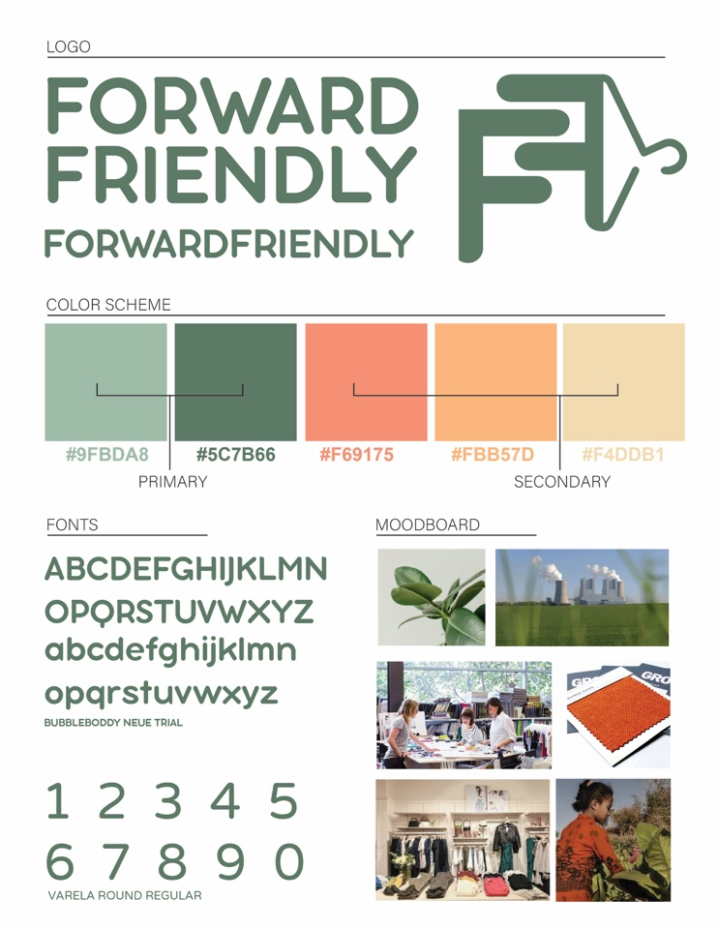

STYLE GUIDE/ MOOD

BOARD

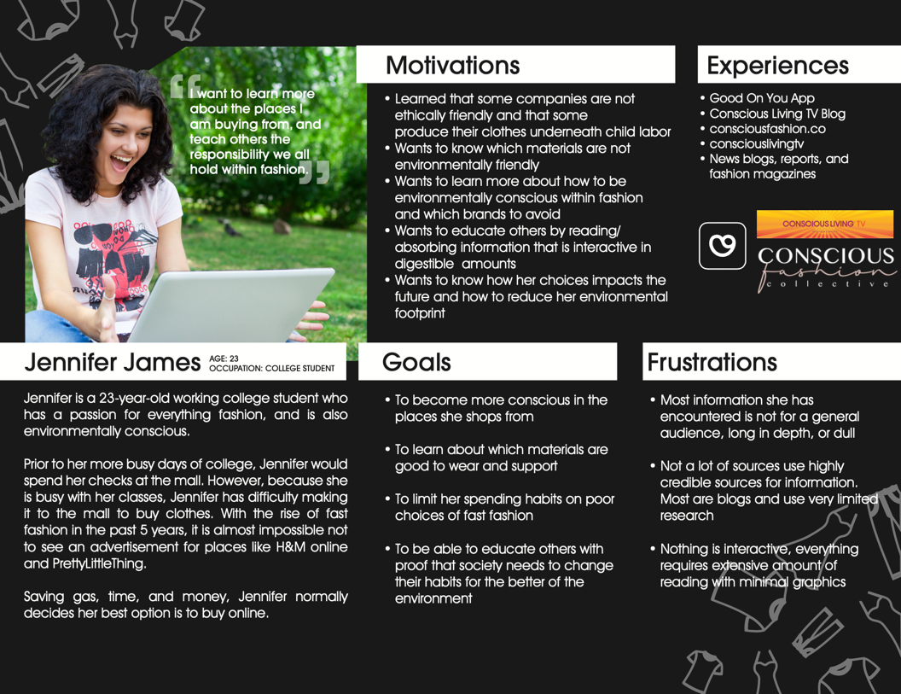

PERSONA

 CONTENT INVENTORY

**Quiz In Ceros:** A quiz for users when they pass the splash page. Creates an interactive environment where their choices impact the future. This will be based on research of the spending habits, materials, and brand choices. Will use photos, refined copy, and data from the content inventory below. Users will have an option to retake the quiz once they have learned more from the website. This option will be in the navigation if they want to see a different outcome in the quiz.

|  |  |  |  |  |
| --- | --- | --- | --- | --- |
| Eco-Friendly & Non Eco Materials |  | Labor Laws | Energy Use | Friendly Forward Tips |
| Picture of Recycled Material for clothes  Type: *Photo and Copy*  Purpose: Eco-Friendly Description of why it is important  Description:  What are they made of?  Where can you find them?  Where do they originate?  How are they made?  How is sustainability improved if used? | Picture of Polyester  **Type:** *Photo and Copy*  **Purpose:** Eco-FriendlyDescription of why it is important  **Description**:  What are they made of?  Where can you find them?  Where do they originate?  How are they made?  How is sustainability improved if not used? | **Type**: *Photo and Copy*  **Purpose:** to explain the labor laws in the US and the freedom of the manufacturing plant management overseas. To explain why it is harmful and unethical  **Description:**  Which companies use child labor? How many?  How many people on average buy from companies that use child labor in their manufacturing plants?  Where are the manufacturing plants located? | **Type:** *Copy and Photo*  **Purpose:** to go in detail how manufacturing plants use harmful tactics and methods that affect the earth.  **Description** | **Type:** *Copy and Hyperlinks/ Anchor text*  **Purpose:** Links to eco-friendly brands to bring light and awareness to use brands that are doing well for the environment  **Description:**  Shows any initiatives that they are doing, breaks down their mission/vision. Shows clothes |
| Hemp  Type: *Photo and Copy*  Purpose: Eco-Friendly Description of why it is important  Description: | Picture of Nylon  Type: ***Photo and Copy***  Purpose: **Eco-Friendly Description of why it is important**  **Description:** | **Type:** Search feature  **Purpose:** To allow the user to type in a company and see their grade for child labor |  | **Type:** *Photos of brand*  **Purpose:** To show brand logos and appropriate clothing that is eco friendly |
| Picture of Soy Silk and Cashmere  Type: *Photo and Copy*  Purpose: Eco-Friendly Description of why it is important  Description: | Picture of Wool  Type: ***Photo and Copy***  Purpose: **Eco-Friendly Description of why it is important**  **Description**: | **Type:** Chart of grades for Worker Empowerment  **Purpose:** to show statistical data of which companies in the report are doing well/bad from 2015 – 2019 in the report | **Type:** *Chart of grades for Water Use and Management + Emissions*  **Purpose:** to show statistical data of which companies in the report are doing well/bad from 2015 – 2019 in the report | **Type:** *Best Practice Testimonials*  **Purpose:** If an informational interview is set up, I will have information that will highlight what TS Designs and Kontoor does in North Carolina to be as eco-friendly as possible |
| Picture of organic cotton  Type: *Photo and Copy*  Purpose: Eco-Friendly Description of why it is important  Description: | Picture of Leather  Type: ***Photo and Copy***  Purpose: **Eco-Friendly Description of why it is important**  **Description**: | **Type:** API Map  **Purpose:** to show the common factories fashion brands use for manufacturing and highlight them interactively on a map | **Type:** API Map  **Purpose:** the same API map from labor laws will be repurposed to highlight the energy use  **Description:**  How much water is used to power machinery?  What is the emissions rate?  How many times a day do they ship out products to those companies? | **Type:** *Parallax Infographic*  **Purpose:** Showing good practices for buying fashion as a recap to this entire website |
| Picture of Linen  Type: *Photo and Copy*  Purpose: Eco-Friendly Description of why it is important  Description: | Picture of Fur  Type: ***Photo and Copy***  Purpose: **Eco-Friendly Description of why it is important**  **Description**: | **Type:** *Data Analytics (R / R Studio)*  **Purpose:** To show the data on a visual scale from the chart comprising of grades from 2015-2019 reports | **Type:** *Data Analytics (R / R Studio)*  **Purpose:** To show the data on a visual scale from the chart comprising of grades from 2015-2019 reports |  |
| Picture of Lensing Tencel  Type: *Photo and Copy*  Purpose: Eco-Friendly Description of why it is important  Description: | Picture of Rayon Viscose  Type: ***Photo and Copy***  Purpose: **Eco-Friendly Description of why it is important**  **Description:** |  |  |  |
|  | Picture of PVC  Type: ***Photo and Copy***  Purpose: **Eco-Friendly Description of why it is important**  **Description:** |  |  |  |

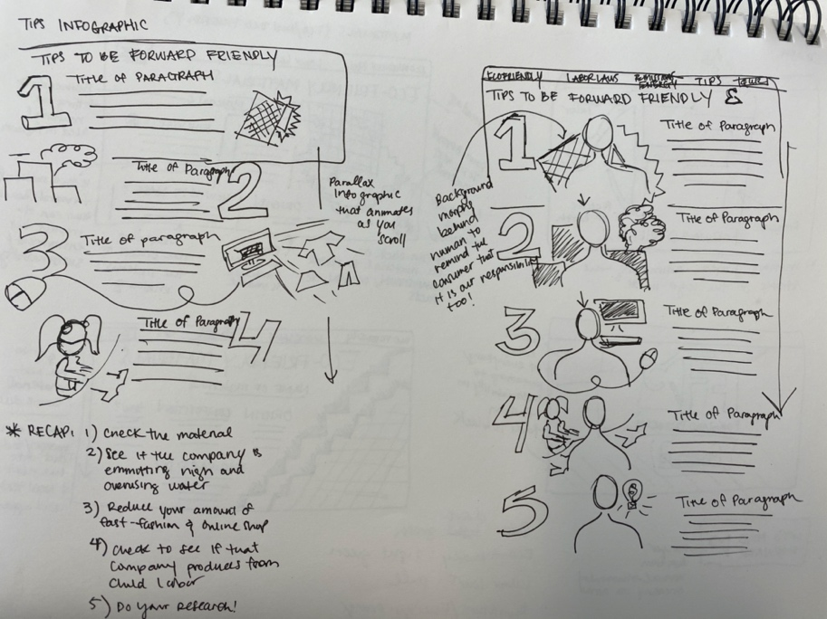SKETCHES

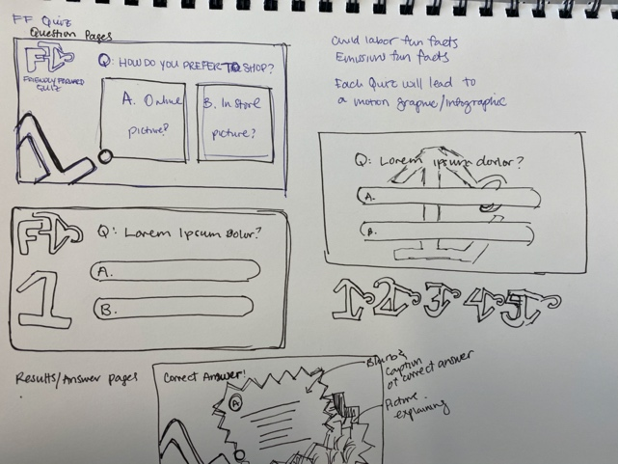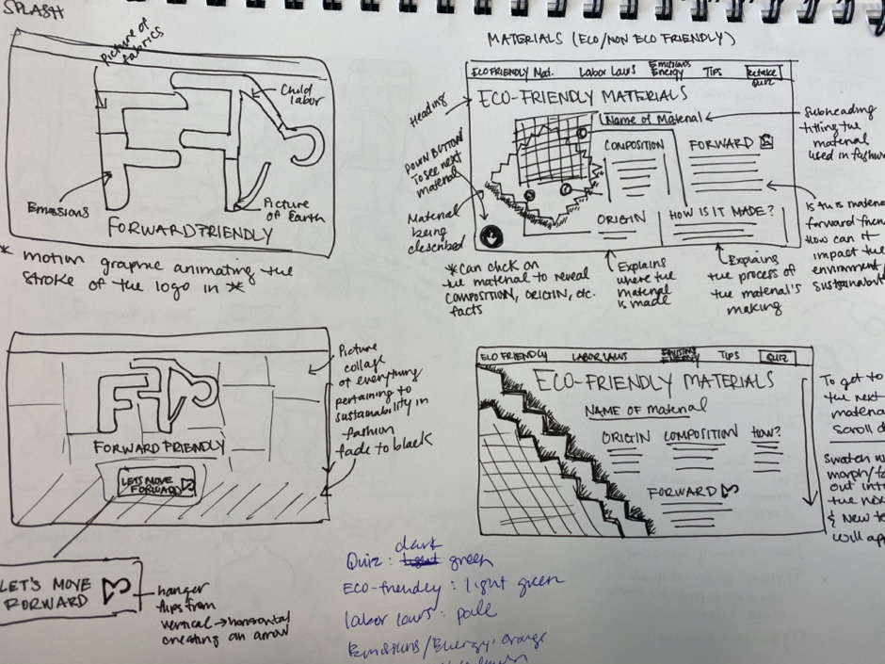

REFLECTION

Creating this project was so much fun, as an apparel designer for The POLAR Movement, LLC. I thought that it would be important to start learning the proper materials to design with. I have learned about child labor and the worker’s conditions in the less managed textile plants. I also learned about how wasteful the fashion industry can be and this project made me want to continue researching to do better for the environment.

Some challenges that I have encountered ranged from data to in person professional experiences:

**I had a lot of trouble finding statistical data in formats that were pleasant to read.** The majority of information I found came from different online publications catered to fashion. However, when it came to hard, open data to create a visualization for the information, I realized that the industry is not kept up to date. There is an extreme need for specific data on child labor, especially within the textile industry.

**Another challenge was photography.** I wanted to get real photos of materials, however I could only get pictures online due to COVID-19. Also, other categories such as child labor would be impossible to get original photos on my own.

A solution for this challenge was using free to use photos from a platform called Unsplash, and crediting other websites at the bottom of the page.

**My in-person scheduled meeting was cancelled** with Kontoor/Wrangler of VF Corporation in Greensboro NC. When COVID-19 worsened, the opportunities for informational interviews in person were extremely limited to none. I wanted to use my connection in Kontoor as a figure of expertise in the fashion industry but that did not transpire, and that is okay.

An accomplishment on the flip side was that I did so much research that it makes up for the fact I did not get professional advice. Having a professional speak about environmental conservation and material science would have been nice.

**My last challenge I would say was bringing all of my information together to be cohesive.** Planning out how all of my research would flow together was time consuming. There is so much to know about material science, child labor, and environmental prevention and if I give it all at one project it could overwhelm the user.

I think a positive side to this was I did overcome this obstacle of feeling overwhelmed. I was able to break down the information into bite size chunks that would be understandable for my audience. I had a great time learning and creating this platform’s content.

**I think my main accomplishment is that I created a fun project.** I created this project with the intention to not bore my user. I wanted my user to be engaged on every single page. From my feedback so far, everyone who has taken the quiz or interacted the site can at least tell me one new thing they have learned.

**I feel like I utilized my design skills to the best of my ability.** I truly feel like I pushed myself. As a graphic designer, I came into this program wanting to build my portfolio and creating a project that is impressive to future employers. I wish that I had coded this project from scratch, however using Wix really was the best idea for me to focus on the elements of design. When I leave this program, I want to use this project to showcase my visual design, user experience, and animation skills to the best of my ability. If time allows in the future, I will even try to hard code this entire website.

CREDITS

Software Used

Website: [www.wix.com](http://www.wix.com)

Quiz: [www.ceros.com](http://www.ceros.com)

Animations: Adobe After Effects

Creations: Adobe Illustrator

Sounds

For animations all sounds came from YouTube Audio Library and did not require accreditation.

Resources

***Eco-Friendly Materials***

<https://www.image.ie/life/sustainable-fabrics-146790>

<https://www.cotton.org/pubs/cottoncounts/story/where.cfm>

<https://www.cottonmill.com/blog/are-all-denim-blue-jeans-made-of-100-cotton/>

<https://goodonyou.eco/material-guide-ethical-denim/>

<https://goodonyou.eco/material-guide-polyester-2/>

<https://sewport.com/fabrics-directory/polyester-fabric>

<https://goodonyou.eco/material-guide-nylon/>

<https://goodonyou.eco/material-guide-ethical-wool/>

<https://goodonyou.eco/the-hidden-costs-of-leather/>

<https://goodonyou.eco/how-ethical-is-fur/>

<https://goodonyou.eco/material-guide-viscose-really-better-environment/>

<https://goodonyou.eco/how-sustainable-is-pvc/>

<https://www.thomasnet.com/articles/top-suppliers/pvc-manufacturers-suppliers/>

<https://www.onegreenplanet.org/news/pharrell-debuts-denim-clothing-collection-made-of-recycled-plastic/>

<https://www.onegreenplanet.org/environment/what-is-the-most-animal-and-eco-friendly-material-for-clothing/>

<https://www.greenlivingshow.ca/blog/>

<https://www.permaculture.co.uk/articles/sustainable-fashion-organic-cotton>

<https://mygreencloset.com/love-linen/>

<https://www.decktowel.com/pages/how-linen-is-made-from-flax-to-fabric>

<https://goodonyou.eco/how-ethical-is-tencel/>

<https://en.wikipedia.org/wiki/Lyocell>

***Child Labor***

<https://labs.theguardian.com/unicef-child-labour/>

<https://www.business-humanrights.org/sites/default/files/documents/FashionReport_2019_9-April-19-FINAL.pdf>

<https://www.fairwear.org/brands>

<https://www.vox.com/2019/9/12/20860620/fast-fashion-zara-hm-forever-21-boohoo-environment-cost>

<https://beeketing.com/blog/zara-growth-story/>

<https://www.goodhousekeeping.com/clothing/g27154605/sustainable-fashion-clothing/>

<https://www.thegoodtrade.com/features/fair-trade-clothing>

***Emissions & Energy***

<https://www.commonobjective.co/article/the-issues-energy>

<https://www.fibre2fashion.com/industry-article/3377/energy-conservation-in-textile-industries-savings>

<https://www.researchgate.net/publication/223060218_Electric_energy_consumption_in_the_cotton_textile_processing_stages>

<https://www.commonobjective.co/article/the-issues-water>

<https://unearthed.greenpeace.org/2019/09/12/fast-facts-about-fast-fashion/>

<https://publications.parliament.uk/pa/cm201719/cmselect/cmenvaud/1952/full-report.html#heading-7>

<https://textechdip.wordpress.com/contents/wet-processing/>

***Quiz Qs***

<https://pollybarks.com/is-shopping-online-more-eco-friendly-than-shopping-local/>

<https://www.rubiconglobal.com/blog/shop-local-reasons/>

<https://www.worldbank.org/en/news/feature/2019/09/23/costo-moda-medio-ambiente>

***Images***

Other images were used from Wix’s free photo services.

ALL MATERIALS FOUND

<https://www.fabricwholesaledirect.com/products/cotton-jersey-knit-fabric?variant=32163958348>

<https://www.fabricgateway.com/topic/hemp>

<https://alabamachanin.com/products/organic-cotton-swatches>

<https://www.blackbirdfabrics.com/tencel-cotton-modal-sweater-knit-mellow-mauve/>

<https://www.alibaba.com/product-detail/cotton-9-5oz-raw-woven-twill_60776537775.html>

<http://www.townsendleather.com/leather/samples/L-VCF-2794>